Drew Crockett
Module 1.2

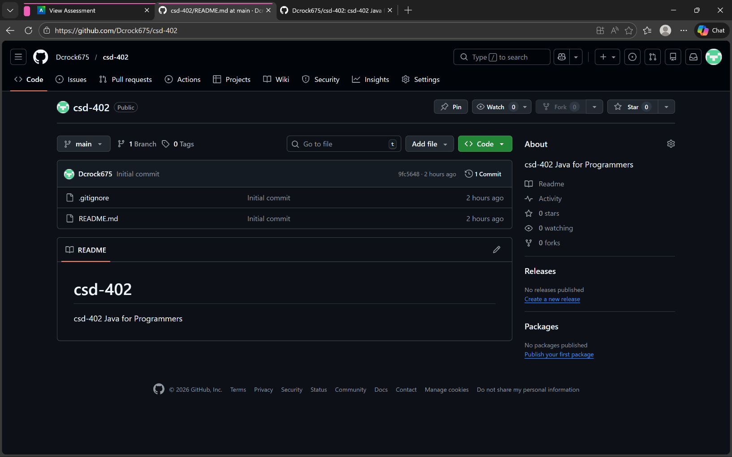
https://github.com/Dcrock675/csd-402.git

